**EXPERIMENT # 8**

**To determine the given high resistance by leakage method.**

**Theory:**

Post office box method for measuring resistance fail to measure high resistances of the order of mega ohms. Such higher resistances are measured by the method of leakage of charge. The discharge of a capacitor through a high resistance R is slow due to the time constant CR being large. This offers a method of measuring high resistance.

**Apparatus:**

1. Damping key
2. Ballistic galvanometer
3. Capacitor
4. Three keys
5. Battery
6. High resistance
7. Connecting wires
8. Stop watch

**Description of apparatus:**

 **Ballistic galvanomenter:**

A ballistic galvanometer is a type of sensitive galvanometer, commonly a mirror galvanometer. Unlike a current measuring galvanometer, the moving part has a large moment of inertia, thus giving it a long oscillation period. It is really an integrator measuring the quantity of charge discharge through it.

 **Capacitor:**

A capacitor also known as condenser is a passive two terminal electrical component used to store electrical energy temporarily in an electric field.

 **Stopwatch:**

A stopwatch is a handheld timepiece designed to measure to the time intervals.

* **Key:**

Key in electric circuits are used to stop or start the flow of current by opening or closing the plug from the key setup respectively.

* **Connecting wire:**

Connecting wire is a piece of wire used to attach two circuits or components together. the gauge or size of wire must be large enough to support the amount of current flow.

**Circuit diagram:**

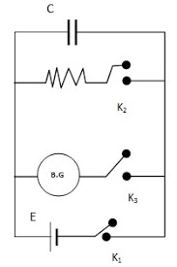

**GRAPH :**

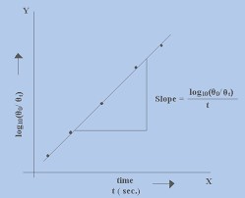

**Procedure:**

1. Make the electric connections as shown in the circuit diagram. Adjust the lamp and the scale arrangement to have a bright spot on the zero of the scale. Now arrange the ballistic galvanometer as such that its coil swing freely on both sides of the center of scale and use damping key to bring the spot on zero position of the scale.
2. Press key k1 for recharging the capacitor. Press key k3 at the same time and release it. Now open the damping key and press key k2, galvanometer will show a rapid deflection. Note the 1st deflection of the galvanometer.
3. Now close the damping key and charge the capacitor, press k3 for a known value of time and note the time using the stopwatch, open the damping key again and press k2 to note the deflection of the galvanometer.
4. Repeat the above mentioned procedure several times and calculate the value of high resistance using the formula given below.

**Formula used:**

# R=

Where, R is the required resistance, c is the capacitance of the capacitor, t is the time period of the leakage of capacitor through the resistance and ⍬ is the deflection of galvanometer at 0 and time, t.

|  |  |  |  |  |
| --- | --- | --- | --- | --- |
| S.No | ⍬ₒ | ⍬t | t (s) | R |
| 1 | 90 | 60 | 4 | 9.8x10 |
| 2 | 80 | 50 | 6 | 12.7x106 |
| 3 | 90 | 50 | 8 | 13.6x106 |
| 4 | 85 | 55 | 4 | 9.19x106 |
| 5 | 85 | 55 | 6 | 13.7x106 |
| 6 | 85 | 55 | 5 | 11.4x106 |

**Precautions:**

1. The galvanometer coil should be made properly free.
2. Damping key should be used across the galvanometer.
3. Capacitor should be free from dielectric loss.
4. After observing ⍬ₒ, the galvanometer coil should be at rest for observing the value.